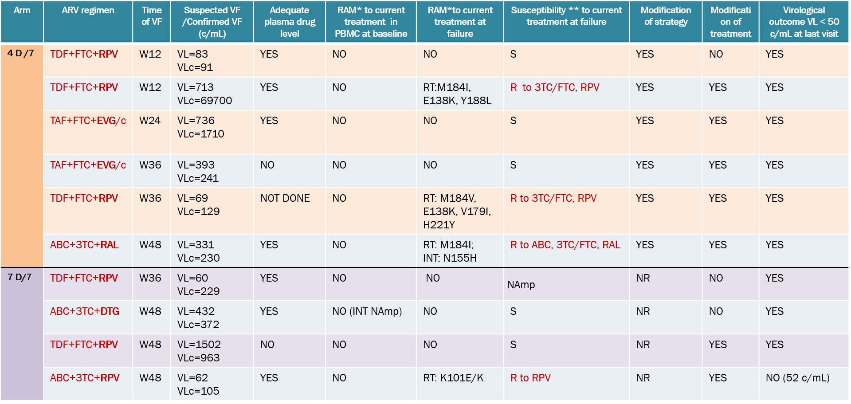

NR : not relevant

**QUATUOR - Confirmed virological failures**

* Sanger sequencing

* * resistance associated mutations According to ANRS algorithm - http://www.hivfrenchresistance.org/index.html

S : susceptibility

NAmp : not amplified

R : resistance